NETWORK COMPONENTS AND TRANSMISSION MEDIA USED

Switch: Cisco Catalyst 2960-X
For the network infrastructure of Jargon Sdn. Bhd., the Cisco Catalyst 2960-X series switches are the most practical and cost-effective choice. The switch is located at each floor to connect all the devices in the office. Renowned for high-quality, reliable networking, these switches ensure stable connectivity crucial for office productivity. It has 24 Gigabit Ethernet ports with line-rate forwarding performance, allowing for the stacking of up to eight switches with a total of 80 Gbps of stacking bandwidth. Hence, The Cisco Catalyst 2960-X series switches provide high performance, advanced security, energy efficiency, and long-term reliability, making them the most practical and cost-effective choice for Jargon Sdn. Bhd.

Cable: UTP CAT6
The cable used to link each device together is UTP CAT6 Ethernet Cable. Most of the modern LAN computer networks use this cable and it is the most commonly used network cable in office environments. This cable consists of 4 twisted wires and a total of 8 wires. Ethernet cables are reliable, relatively inexpensive, and easy to install. These cables support up to 1 Gigabit network speeds over 100 meters and 10 Gigabit speeds over shorter distances of 55 meters. It also reduce system noise and signal loss due to their tighter twists and stricter specifications for crosstalk, resulting in more reliable network connections.

Router: Cisco ISR 4331
It is one of the Cisco 4000 Series Integrated Services Routers. It provides routing, hosting, security, and switching all in a single. It also simplify the network architecture and reducing the need for multiple devices. The built-in security features, such as firewall, VPN, and threat defense, ensure robust protection against cyber threats, enhancing the overall security posture of the office network. Compared to other routers like the HP MSR1003-8 and Juniper SRX300, the Cisco ISR 4331 offers superior modularity and a more comprehensive set of integrated services

Wireless Access Points (WAPs): Cisco Meraki MR36
For Jargon Sdn. Bhd.'s office network, the Cisco Meraki MR36 wireless access point is the optimal choice, providing high-performance Wi-Fi 6 connectivity with advanced security features. Placed on each floor of the office. The MR36 is designed for high-density environments, ensuring seamless connectivity for all users and devices. Advanced security features such as WPA3, firewall, and self-configuring capabilities ensure excellent connectivity and protection for all applications and data. The MR36 is ideal for modern hybrid and mobile work environments, catering to a moderate number of users and devices while providing reliable network access for laptop and mobile workers.

Firewall: Cisco Firewall 3140
It is offering modern security features and centralized control, and this series provides the necessary throughput, port density, and cybersecurity for environments ranging from branch offices to global enterprises. Compared to other firewalls like the Palo Alto Networks PA-220 and Fortinet FortiGate 100F, the Cisco Firewall 3140 offers higher inspection throughput and application-based quality of service (QoS), to ensuring secure and reliable access to applications like video conferencing.

Printers: Epson EcoTank ET-4760

For Jargon Sdn. Bhd.'s office environment, the Epson EcoTank ET-4760 inkjet printer is the ideal choice. With two printers on the 1st floor and one on the 2nd floor ,it will accommodate the workforce distribution. The ET-4760 offers versatile functionality, fast printing speeds, and cost-effectiveness. It is also a multifunction printer that supports printing, scanning, faxing, and copying. Its larger display screen simplifies operation and it is able to print up to 15 pages per minute in black and 8 pages per minute in color to ensures efficient workflow. Compared to other printers like the HP OfficeJet Pro 9015 and Canon PIXMA G6020, the Epson EcoTank ET-4760 offers comparable functionality with lower long-term operating costs.

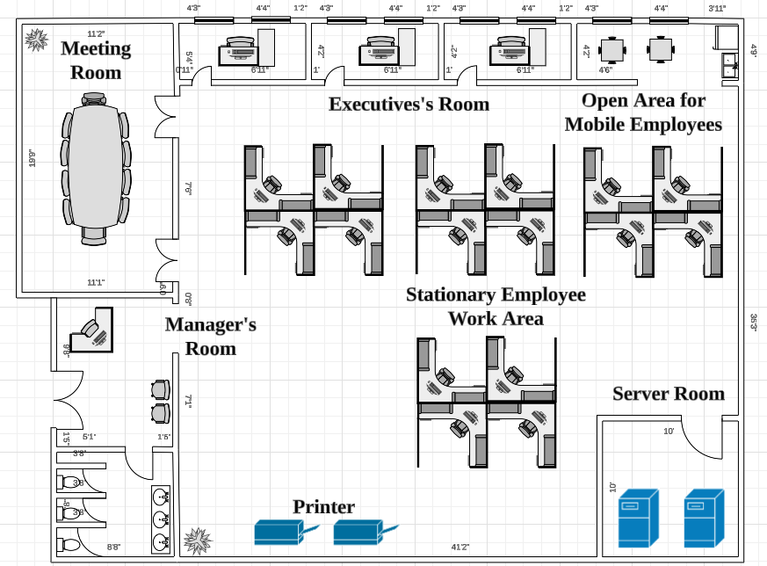
Figure shows how the device will be placed.

